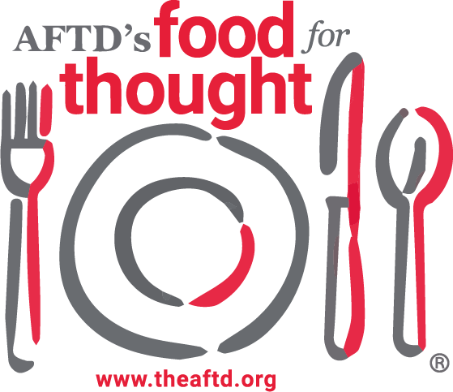
DATE

To Whom It May Concern,

Food for Thought (FFT) is a grassroots fundraising campaign that focuses on food and FTD education. FFT 2025 is the 13th annual campaign taking place from September 21 through October 5, 2025. During this time frame, NAME will be hosting “Title of Event” in your local area. Description of Event. Funds raised for this event will be donated to The Association for Frontotemporal Degeneration (AFTD) to support their mission.

AFTD is a national nonprofit organization (EIN: 47-2073220) whose mission is to improve the quality of life of people affected by frontotemporal degeneration (FTD) and drive research to a cure. FTD is a rare brain disorder that causes impairment in personality, language, behavior and/or movement. It is a progressive disease with onset occurring most often in the 40’s – 60’s and thus impacts family and finances in a way that more common forms of dementia do not. AFTD is dedicated to funding research for development of effective treatments as well as to developing resources and education programs for professionals and families.

Today, the diagnosis of FTD comes with no treatment and no cure. I seek your support in making Name’s event a success by supporting our efforts to achieve AFTD’s vision of “a world where FTD is understood, effectively diagnosed, treated, cured and ultimately prevented”. Preferred support would be in the form of support requested. This gift would cover the costs of insert expense so 100% of the funds donated can be delivered to AFTD’s mission of improving the quality of life of people affected by FTD and drive research to a cure. This includes our five pillars of research, awareness, support, education, and advocacy.

If you have any questions or need additional information, please contact me at either jshellenberger@theafdtd.org or 484-584-0162.

Thank you,

